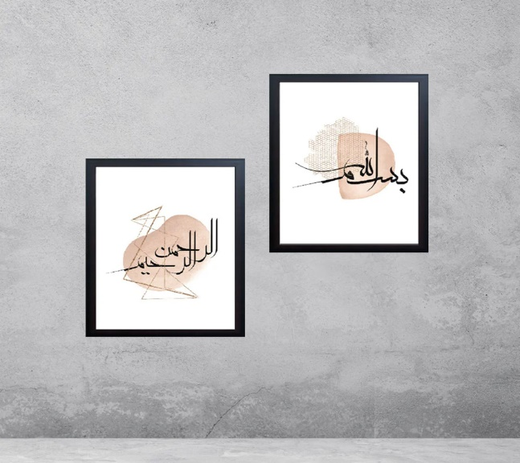**2 PCS Islamic Photo Frames**

This image displays two framed abstract art pieces with Arabic calligraphy, elegantly mounted on a minimalist grey wall. The designs incorporate soft beige tones with geometric and textured elements, blending traditional calligraphy with modern artistic styles. The simplicity of the frames and the neutral background highlight the intricate details of the artwork, creating a harmonious and sophisticated aesthetic.